Privileges and immunities
Ben Jaffey QC
Blackstone Chambers

Belhaj
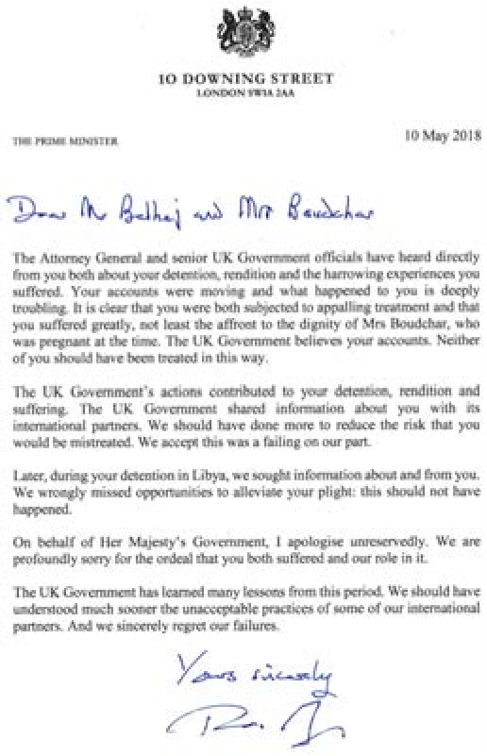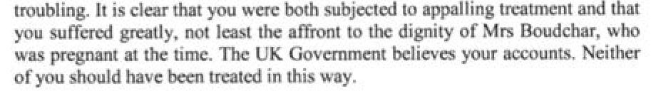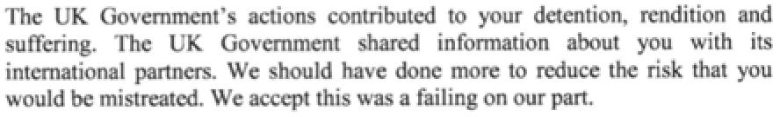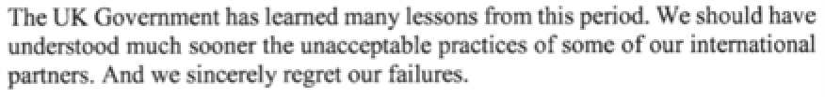
Belhaj
Others
- Rahmatullah (No. 1)
- Serdar Mohammed (detention in NIAC)
- Serdar Mohammed JR (safety on transfer)
- SIAC litigation on Libya/Algeria

Topics
State immunity
- Diplomatic Immunity
- Special Mission Immunity
- Immunity for documents
- S. 7 ISA 2004, statutory Crown Act of State

ALBA Pub Quiz
- Can I sue the Saudi Government for torturing me abroad?
- Can I sue the officials that tortured me?
- Will the Courts decide if I was tortured in a safety on return case?
- Can I sue HMG if it was complicit in torture abroad?

ALBA Pub Quiz
I am a modern slave working for the Saudi embassy. Can I bring an employment claim?
- Does it make a difference if my employer is a diplomat?
- Can the modern slave use the document she stole from the embassy to prove her case?

State Immunity
- Jones v Saudi Arabia
- Belhaj
- Benkharbouche
Diplomatic Immunity
Al-Malki 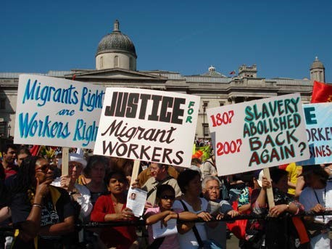

Diplomatic Immunity
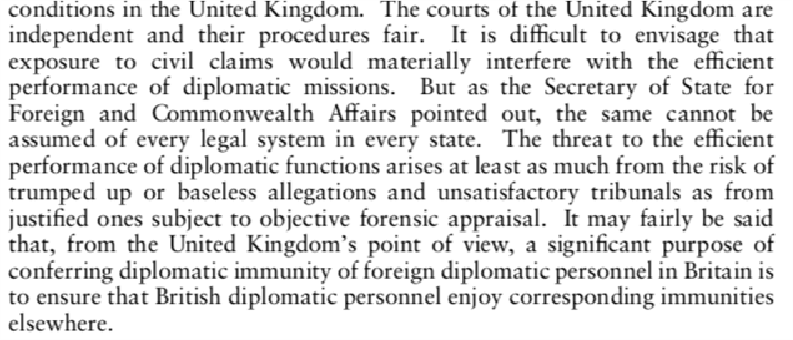
Diplomatic Immunity
Al-Malki
- Lost immunity after left post • Immunity for modern slavery in post?
- Tension between fairness in the UK against protections for diplomats abroad

Special Missions
• R (Freedom & Justice Party) v SSFCA

Special Missions
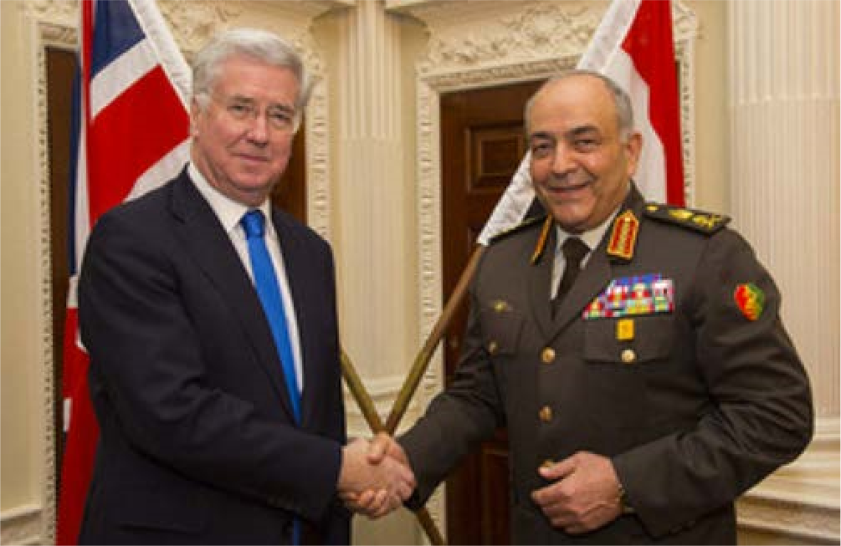
Special Missions
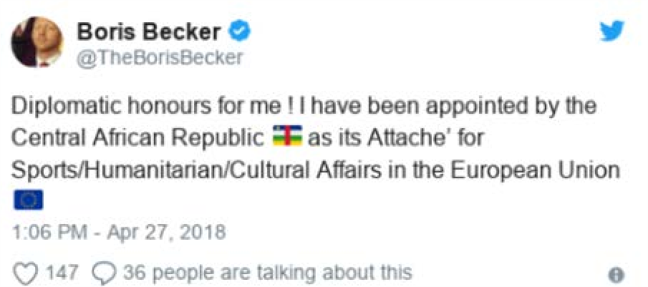
Special Missions
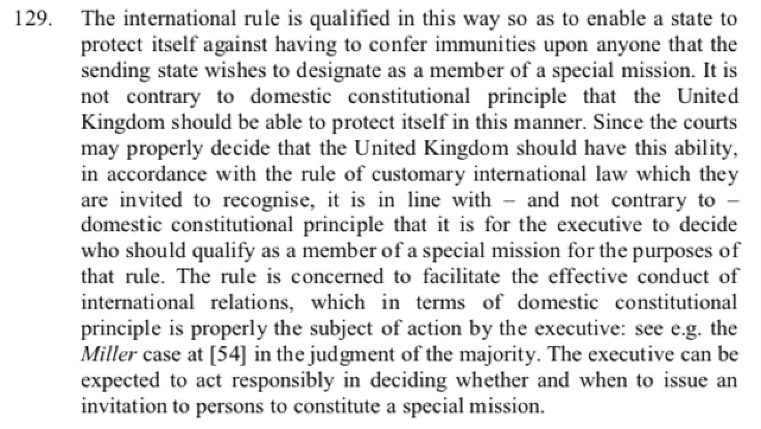

Immunity for Documents
• R (Bancoult) v SSFCA (No. 3)
Immunity for Documents
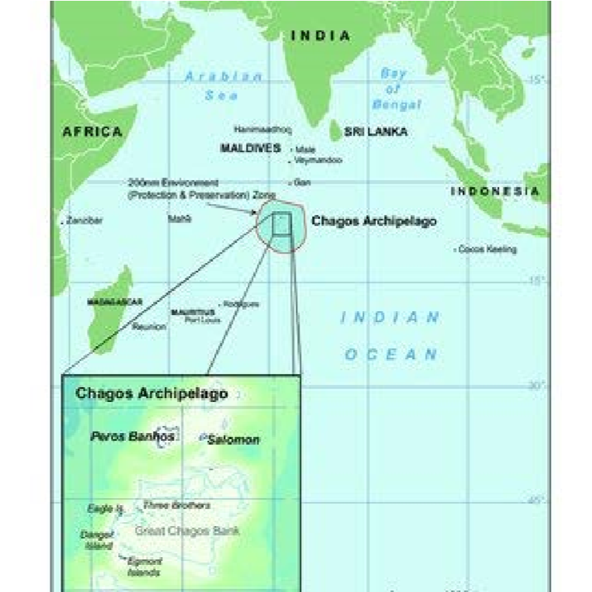

Immunity for Documents
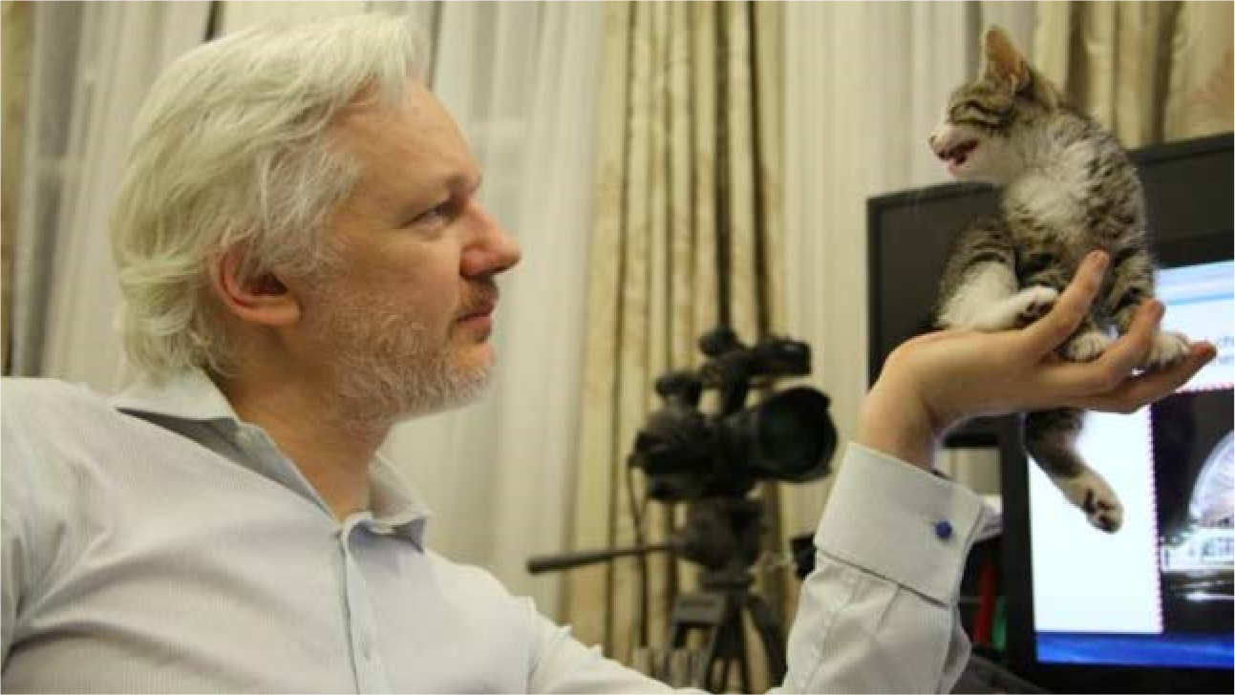
Immunity for Documents
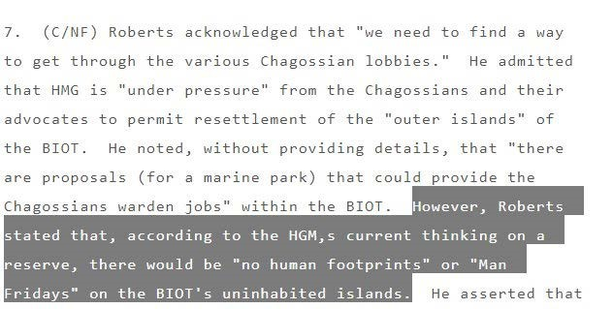
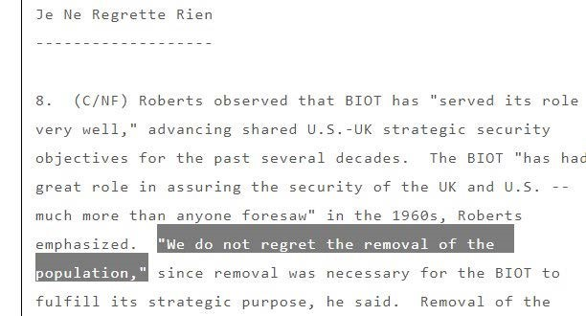

Immunity for Documents
• R (Bancoult) v SSFCA (No. 3)
- Under control of embassy
- Not in public domain

s. 7 ISA 2004
Authorisation of acts outside the British Islands.
(1)If, apart from this section, a person would be liable in the United Kingdom for any act done outside the British Islands, he shall not be so liable if the act is one which is authorised to be done by virtue of an authorisation given by the Secretary of State under this section.
(2)In subsection (1) above “liable in the United Kingdom ” means liable under the criminal or civil law of any part of the United Kingdom.
(3)The Secretary of State shall not give an authorisation under this section unless he is satisfied—
(a)that any acts …will be necessary for the proper discharge of a function of the Intelligence
Service or GCHQ; and
(b)that there are satisfactory arrangements in force to secure—
(ii)that, in so far as any acts may be done in reliance on the authorisation, their nature and likely consequences will be reasonable, having regard to the purposes for which they are carried out
s. 7 ISA 2004
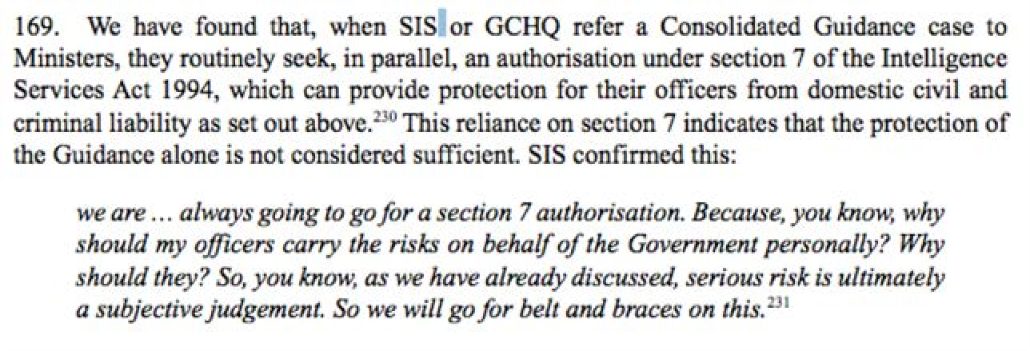
s. 7 ISA 2004
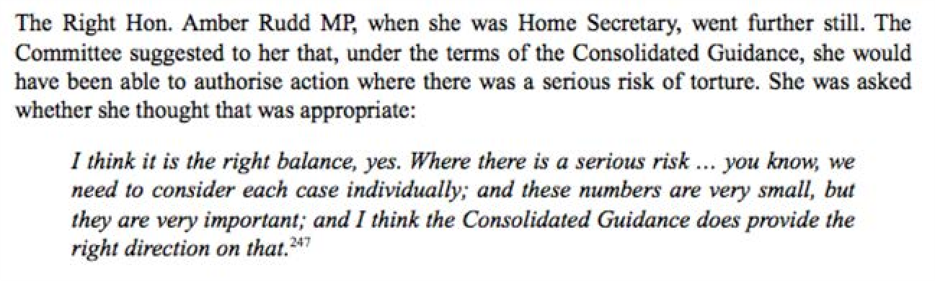
Ben Jaffey QC
www.blackstonechambers.com

